Dear AP Chemistry Student,
I’m excited that you are taking AP Chemistry in the 2026-2027 school year with me. This is a hard class that requires dedication, a lot of work and a love for chemistry.
AP Chemistry is meant to be a second-year course. That is, there is a lot of new material to cover and very little time to go over topics we studied in 10th grade Chemistry. However, because Chemistry is comprehensive, we can’t forget about all the concepts learned in the last school year. To that end, I’ve put together this notes and problems packet for you to complete during the summer. Don’t try to do it all at once – but practicing a little at a time every few days will help to flex those brain muscles over the summer. Please join my youtube channel (https://youtube.com/playlist?list=PLvOP8Dfba2lSn0PiatFZj6e3ZzsgRG_G2). Videos are posted on this playlist that will assist with your summer packet. Please email me (Marissa.lehmann@k12.dc.gov) if you have any questions or need any additional support. I will be checking my email about once a week during the summer.
At the end of the first week of class, I will evaluate your completion of this packet and you will take the first assessment in AP Chemistry. The practice quiz is the last page of this packet. If you make an effort to review this material, I don’t anticipate you having any difficulty with the first test.
In that spirit, enjoy your summer and I look forward to a new year of AP Chemistry with you.
All the best,
Mrs. Lehmann
Part 1: Rearranging Equations
Look at the equation sheet on the previous page. During 10th grade chemistry you should have learned the equation for density. Find that equation on the equation sheet and circle it.
- Equation for density:

- Rearrange the equation to solve for volume:

Look at the equation sheet on the previous page. During 10th grade chemistry you should have learned the equation for energy, q. Find that equation on the equation sheet and circle it.
- Equation for energy:

- Rearrange the equation to solve for specific heat:

Look at the equation sheet on the previous page. During 10th grade chemistry you should have learned the equation for molarity, M. Find that equation on the equation sheet and circle it.
- Equation for Molarity:

- Rearrange the equation to solve for moles
Part 2: Significant Figures and Scientific Notation

- Determine the number of significant figures in each of the following numbers.

a. | ______ 1,245m | e. | _______ 0.035m
b. | _______ 10,000m | f._______ 1.340 x 10²³m
c. | _______ 3.08003 x 10¹⁴m | g. | _______ 0.0000001m
d. | _______ 1,000. mol | h. | _______ 0.10000010

- Round each number to two significant figures.
a. | __________ 1,275m | e. | ___________ 0.035 m
b. | ___________ 10,000m | f.___________ 1.340 x 10²³m
c. | ___________ 3.08003 x 10¹⁴m | g. | ____________ 0.0000001m
d. | ___________ 1,000. mol | h. | ____________ 0.10000010

- Convert the following numbers into standard scientific notation:

  - 96.3 x 10⁴ g ____________________

  - 0.05 x 10²³ s ____________________

  - 123 x 10⁻⁷ m ____________________

- Convert the following numbers into scientific notation:

- 23000000 g __________________

- 0.003420 mol ________________

- 0.00010 L ___________________

- Write the following number in scientific notation with 3 significant figures: 24376234 mL
Part 3: Metric Conversions
Make the following conversions – preserve the number of significant figures in the answer!

1. |  | 450nm ____________________ mm | 2. | 34km ______________________cm
3. | 43 000mm _____________________m |  | 4. | 4.0 x 10⁶ nm __________________µm
5. | 3.98 x 10⁻³km ___________________m |  | 6. | 456mm ______________________km
7. | 136 000m _____________________km |  | 8. | 4.89 x 10¹² mm ________________km
9. | 2.68 x 10⁶ m __________________km |  | 10. |  | 456 000 µm _________________mm
11. |  | 450mm ____________________m | 12. |  | 23cm _____________________mm
13. |  | 234 µm __________________cm | 14. |  | 2.34 x 10⁴ cm _________________m
15. |  | 4.56 x 10⁻⁷ cm __________________nm

Part 4: Dimensional Analysis

- I have 470 milligrams of table salt, which is the chemical compound NaCl. How many mL of NaCl solution can I make if I want the solution to be 0.90% NaCl? (9 grams of salt per 1000 grams of solution). The density of the NaCl solution is 1.1 g solution/mL solution.

- In a lab, a student collected 0.52 g of silver metal (Ag). The price of silver currently is $78.78 per ounce. How much is the silver worth? (Note: 1 ounce = 28.35 g)

- If the recommended daily amount for vitamin C is 60. milligrams per day and there are 70. mg of vitamin C per 100. grams of orange, how many oranges would you have to eat each week to meet this requirement? The average orange has a mass of 5.2 ounces. (Note: 1 ounce = 28.35 g)

Part 5: Atomic Structure
- Fill in the labels for the model of the atom below.
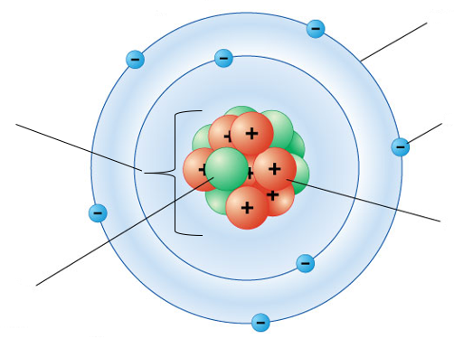
- How can you determine the mass of an atom?

- How can you determine the charge of an atom?

- Which subatomic particle (protons, neutrons, or electrons) dictates an atom’s identity?

- Define isotope and ion.

Element or Ion | Atomic Symbol | Atomic Number | Atomic Mass | Charge | Protons | Neutrons | Electrons
Oxygen |  |  | 16 |  |  |  | 8
 | Br¹⁻ |  |  |  |  | 46
 |  |  |  |  | 13 | 14 | 13
 |  | 28 | 59 | +3
Sodium |  |  |  |  |  | 12 | 10
 | Mn⁵⁺ |  | 56
 |  | 9 |  | -1 |  | 10
Part 6: Average Atomic Mass
- The periodic table shows the average atomic mass for each element.
  - What is the average atomic mass of chlorine? ___________
  - Below is a mass spectrum of chlorine. Use it to calculate the average atomic mass of chlorine.
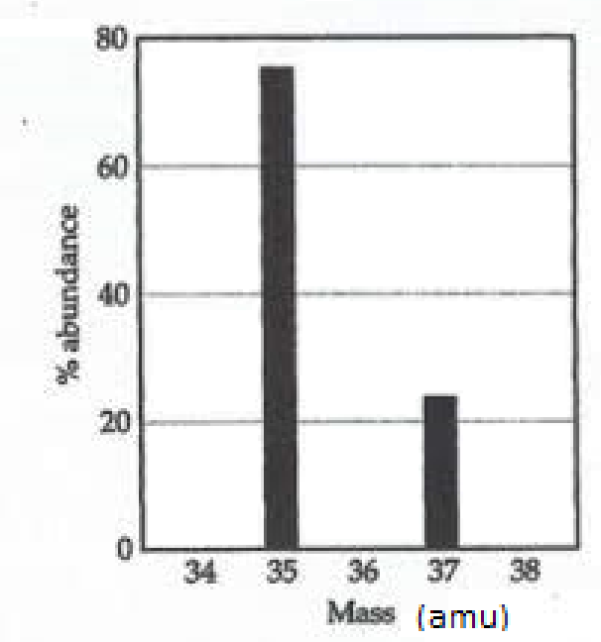
  - How accurate was your calculation?

- Magnesium has three isotopes. The number of neutrons and the natural abundance of these are: 12 neutron (79.0%); 13 neutrons (10.0%); and 14 neutrons (11.0%).
  - Calculate the average atomic mass for magnesium.

  - On the axes below, sketch a mass spectrum for magnesium. Be sure to label the axes.
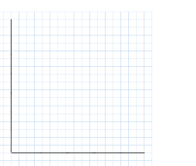
Part 7: Electron Configurations
In the space below, write the electron configurations of the following elements:

1. | Oxygen | ________________________________________________
2. | Chlorine | ________________________________________________
3. | Sodium | ________________________________________________
4. | Aluminum | ________________________________________________
5. | Argon | ________________________________________________
6. | Iron | ________________________________________________

7) | 1s²2s²2p⁶3s²3p⁵ | ____________________
8) | 1s²2s²2p⁶3s²3p⁶4s²3d¹⁰4p⁶5s²4d¹ | ____________________
9) | 1s²2s²2p³ | ____________________
10) | 1s²2s²2p⁶3s²3p⁶4s²3d¹⁰4p⁶5s²4d¹⁰5p⁶6s²4f¹⁴5d⁶ | ____________________
11) | 1s²2s²2p⁶3s²3p⁶4s²3d¹⁰4p³ | ____________________
Determine what neutral element is denoted by each of the following electron configurations:

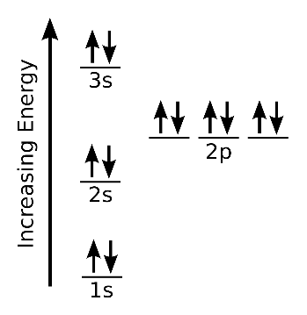
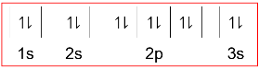
Draw the orbital diagrams for the following elements: Example: Mg or

- Nitrogen

- Sodium

- Chlorine
Part 8 Periodic Table and Trends

- On the AP Chemistry periodic table on the next page, color and label:
  - alkali metals
  - alkaline metals
  - transition metals
  - nonmetals
  - metalloids
  - halogens
  - noble gases

- On the AP Chemistry periodic table on the next page, color and label.
  - the s block
  - the p block
  - the d block
  - the f block

- On the AP Chemistry periodic table on the next page, draw arrows to show the following periodic trends across each period and down each group. Be sure to label which way the trend is increasing and which way it is decreasing.
  - Atomic radius
  - Ionization energy
  - Electronegativity

- Memorize the following elements, atomic number, and symbols.
  - Elements #1 – 56, 79, 80, 82, 86, 92.
Part 9: Ionic and Covalent Compounds

Fill in the symbols and charges of the ions and then write the correct chemical formula.
Ions | Sodium  Na⁺ | Calcium | Aluminum | Ammonium | Hydrogen
Chloride  Cl⁻ | NaCl
Nitrate
Oxide
Sulfate
Phosphate
Iodide

Part VI: Problems - More Naming Practice!
Write the name or chemical formula of each compound. Then indicate if it is ionic or covalent.
Ionic or Covalent?
- Vanadium (V) sulfate ____________________ _______
- Sodium nitrate ____________________ _______
- MnF₂ ____________________ _______
- Ni(SO₄)₂ ____________________ _______
- Phosphorous triiodide ____________________ _______
- H₂O ____________________ _______
- Nitrogen trifluoride ____________________ _______
- Pb₃N₄ ____________________ _______
- Sn(OH)₂ ____________________ _______
- CCl₄ ____________________ _______
Part 7: Notes on Mole Conversions are on the electronic version of the AP Chemistry Summer Review Packet

- How many moles are 1.20 x 10²⁵ atoms of phosphorous?

- How many molecules are in 0.400 moles of N₂O₅?

- Find the number of moles of argon in 452 g of argon.

- Find the grams in 1.26 x 10⁻⁴ mol of HC₂H₃O_{2.}

- Find the mass in 2.6 mol of lithium bromide.

- What is the volume of 1.2 moles of water vapor at STP?

- Determine the volume in liters occupied by 14 g of nitrogen gas at STP.

- Find the mass, in grams, of 1.00 x 10²³ molecules of N_{2.}

- How many particles are there in 1.43 g of a molecular compound with a gram molecular mass of 233 g?

AP Chemistry Summer Assignment Practice Quiz

You are expected to know all of the information in the summer packet. You will be quizzed on that information on the first Friday of the school year. This document is a practice quiz. While the questions on the actual quiz will not match these questions, they will be very similar. If you perform well on this practice quiz, you should be prepared for graded quiz.

- c = λν means c, the speed of light, is equal to wavelength (λ) times frequency (ν). Rearrange this equation to solve for wavelength.

- Examine the quantity 992000000 nm.
  - Convert it into scientific notation.
  - How many significant figures does it have?
  - Convert it into meters.
- How many grams of Mg metal will be produced in 45 seconds by a current that is 3.00 Coulombs/second? 96,485 coulombs of electrons are equal to 1 mol of electrons and Mg loses 2 electrons. The molar mass of Mg is 24.30 g/mol. (3.00 Coulombs = 1 second; 96, 485 Coulombs = 1 mol of electrons; 2 moles of electrons = 1 mol of Mg)

- An atom is composed of 50 protons, 69 neutrons, and 48 electrons.
  - What element is this?
  - What is the mass of this atom?
  - What is the charge of this atom?
- An ion of bromine has a mass of 80 amu.
  - What is the charge of this ion and how do you know?
  - How many protons, neutrons, and electrons does this ion have?
- Write the electron configuration for a neutral atom of vanadium.
- Draw the orbital diagram for a neutral atom of silicon.

- List three halogens.

- Which atom has a larger radius, phosphorous or silicon?

- Write the chemical formula for the following compounds.
  - Sodium phosphate
  - Silicon tetrahydride
  - Copper (II) nitrate
  - Calcium phosphide
- Write the chemical name for the following compounds.
  - PS₃
  - RuSO₄
  - SrCl₂
  - CO
- What is the mass of 4.5 x 10²⁴ molecules of H₂O? Your answer must have the proper number of significant figures.

